***AWS & DEVOPS***

***DEVOPS = DEVELOPMENT+OPERATIONS***  
  
1. What is Devops? ----- PCB – TR – DOM where

P = plan, C = Code, B = Build,

T= Test, R = Release

D= Deploy, O= Operate, M = Monitor

Devops is a set of packages and tools and is a culture that automate anything in the process in software development.

2. In AWS we set up infrastructure and to automate that infrastructure or to maintain it we need Devops. When we combine both of this the entire infrastructure will be fantastic.

For example: assume we have 100 servers its very hard to launch 100 servers manually so with the help of devops tools we can automate it

* **SERVER-BASE v/s SERVER-LESS**

SERVER-BASE ---- Where we need to maintain our virtual servers by ourselves

SERVER-LESS ---- Without any sing server we can setup our entire application

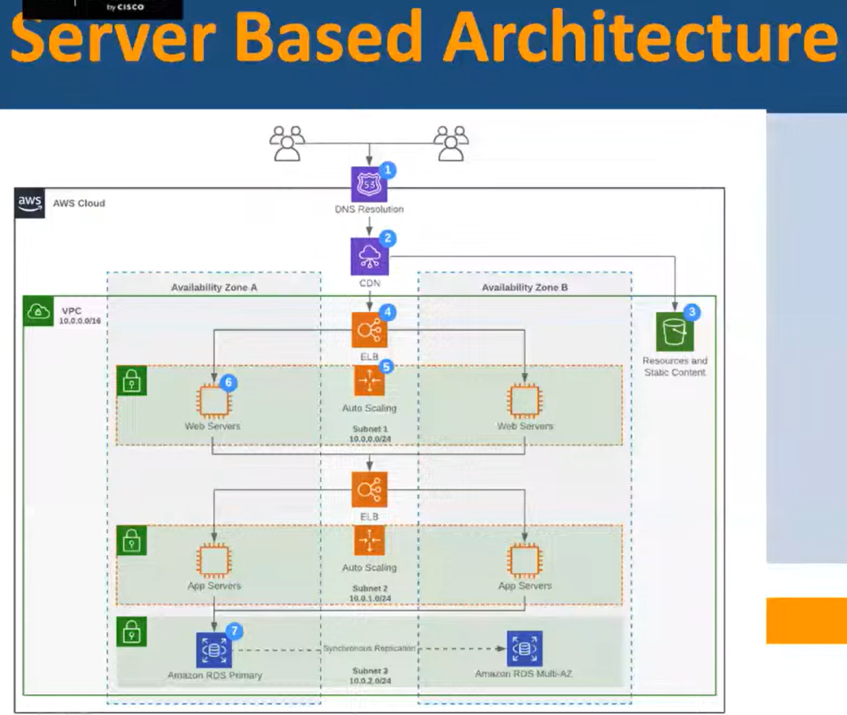

* **MONOLITHIC & MICROSERVICES ARCHITECTURE**

MONOLITHIC ARCHITECTURE ----- In this architecture all our application is packed up and then connected to one database, so anything happens to any layer in the architecture the next layer will also face the problem and everything will be collapsed, which is very danger to our application.

MICROSERVICES ARCHITECTURE ------- Here we are just separating the services like UI and business layer, data interface will we separate services.

